The given data is as follows:

Sample size, n = 500

People who opted for L (Large) size = 200

People opting for XL = 300

Problem statement: There are a total of 100k people in a company and T-shirts are to be ordered for all of them, but we have choices only from 500 people.

We need to come up with a reliable number for L and XL size T-shirts for the 100k people.

################################### SOLUTION #################################

We are going to take the number of L choices made by the sample set of 500 people and come up with a reliable number for 100k people

Assumptions:

1. Sample mean, x̄ = 200
2. Confidence interval, CI = 95%
3. Population Std. deviation, σ = 50

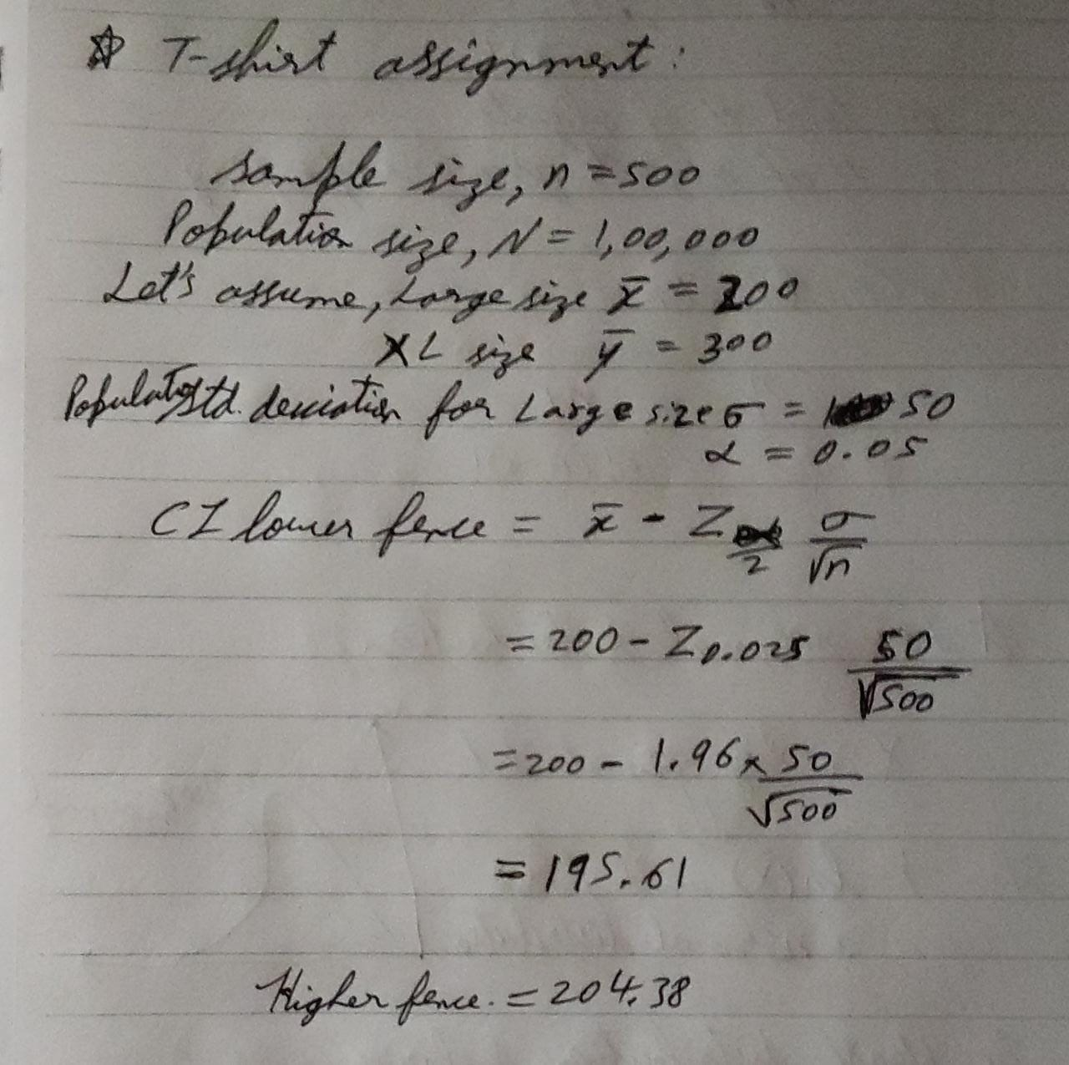

We will take the lower-fence value, rounding in up to 196 for size L in a sample size of 500 and extrapolate the same for 100k population size.

i.e. Number of T-shirts in size L = 39,200

And hence T-shirts in size XL = 60,800

The reason for choosing lower fence value is to make sure the T-shirts are usable even if they are not the right fit. People on the borderline can still use up higher size XL size T-shirts if the actual number of people with L size are more than 39200. But if we go with the Higher fence value of 205 and people with size XL happen to be more than our calculation they wont be able to wear a smaller size and end up with no T-shirt and there would also be a few T-shirts which nobody can use.